Lab 01:

Task 01:

Form:

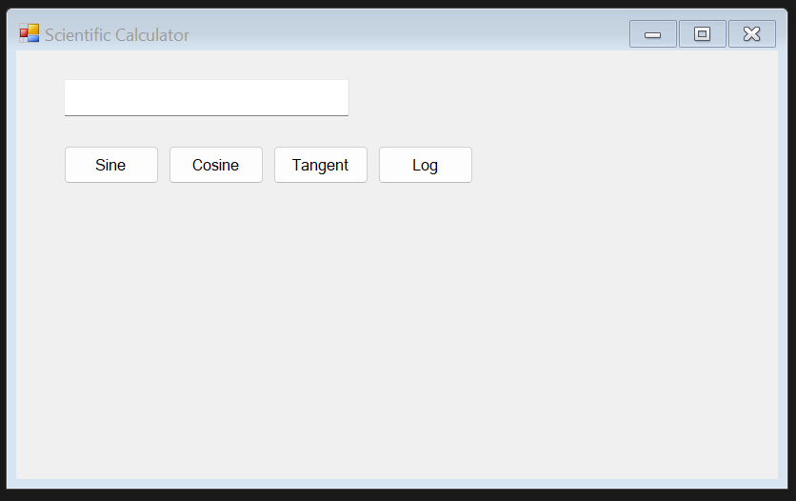

Code :

using System;

using System.Collections.Generic;

using System.ComponentModel;

using System.Data;

using System.Drawing;

using System.Linq;

using System.Text;

using System.Threading.Tasks;

using System.Windows.Forms;

namespace CCLab1

{

public partial class Form1 : Form

{

public Form1()

{

InitializeComponent();

}

private void btnSine_Click(object sender, EventArgs e)

{

double input = double.Parse(txtInput.Text);

txtInput.Text = Math.Sin(input).ToString();

}

private void btnCosine_Click(object sender, EventArgs e)

{

double input = double.Parse(txtInput.Text);

txtInput.Text = Math.Cos(input).ToString();

}

private void btnTangent_Click(object sender, EventArgs e)

{

double input = double.Parse(txtInput.Text);

txtInput.Text = Math.Tan(input).ToString();

}

private void btnLog_Click(object sender, EventArgs e)

{

double input = double.Parse(txtInput.Text);

txtInput.Text = Math.Log(input).ToString();

}

}

}

Output:

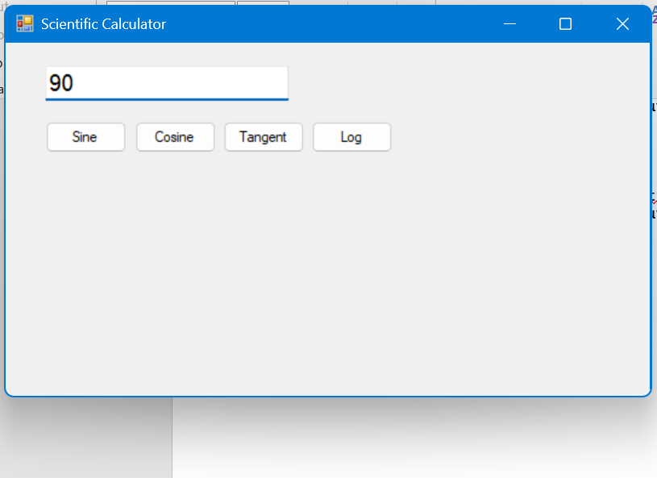

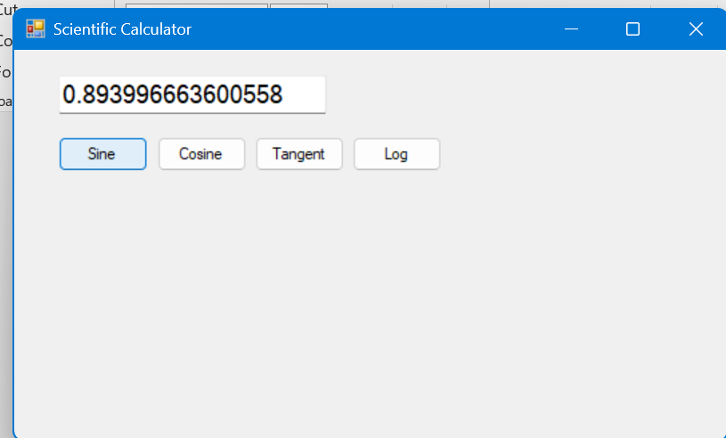

Task 02:

Code:

using System;

using System.Collections.Generic;

using System.ComponentModel;

using System.Data;

using System.Drawing;

using System.Linq;

using System.Text;

using System.Threading.Tasks;

using System.Windows.Forms;

namespace CCLab1

{

public partial class Form2 : Form

{

public Form2()

{

InitializeComponent();

}

private void btnAddRow_Click(object sender, EventArgs e)

{

// Example values

string name = "John Doe";

int age = 30;

string city = "New York";

// Add a row to the DataGridView

dataGridView1.Rows.Add(name, age, city);

}

private void Form2_Load(object sender, EventArgs e)

{

// Add columns programmatically

dataGridVie outw1.Columns.Add("Name", "Name");

dataGridView1.Columns.Add("Age", "Age");

dataGridView1.Columns.Add("City", "City");

}

}

}

Output:

